**Documentation for applying Patch manually**:

Step 1: Go to D:\TDC\TDC-8-20230302\TalendDataCatalog

Step 2: click on tomcat and bin

Step 3: Right click on shutdown.bat and click on run as administrator

As shown in below image.

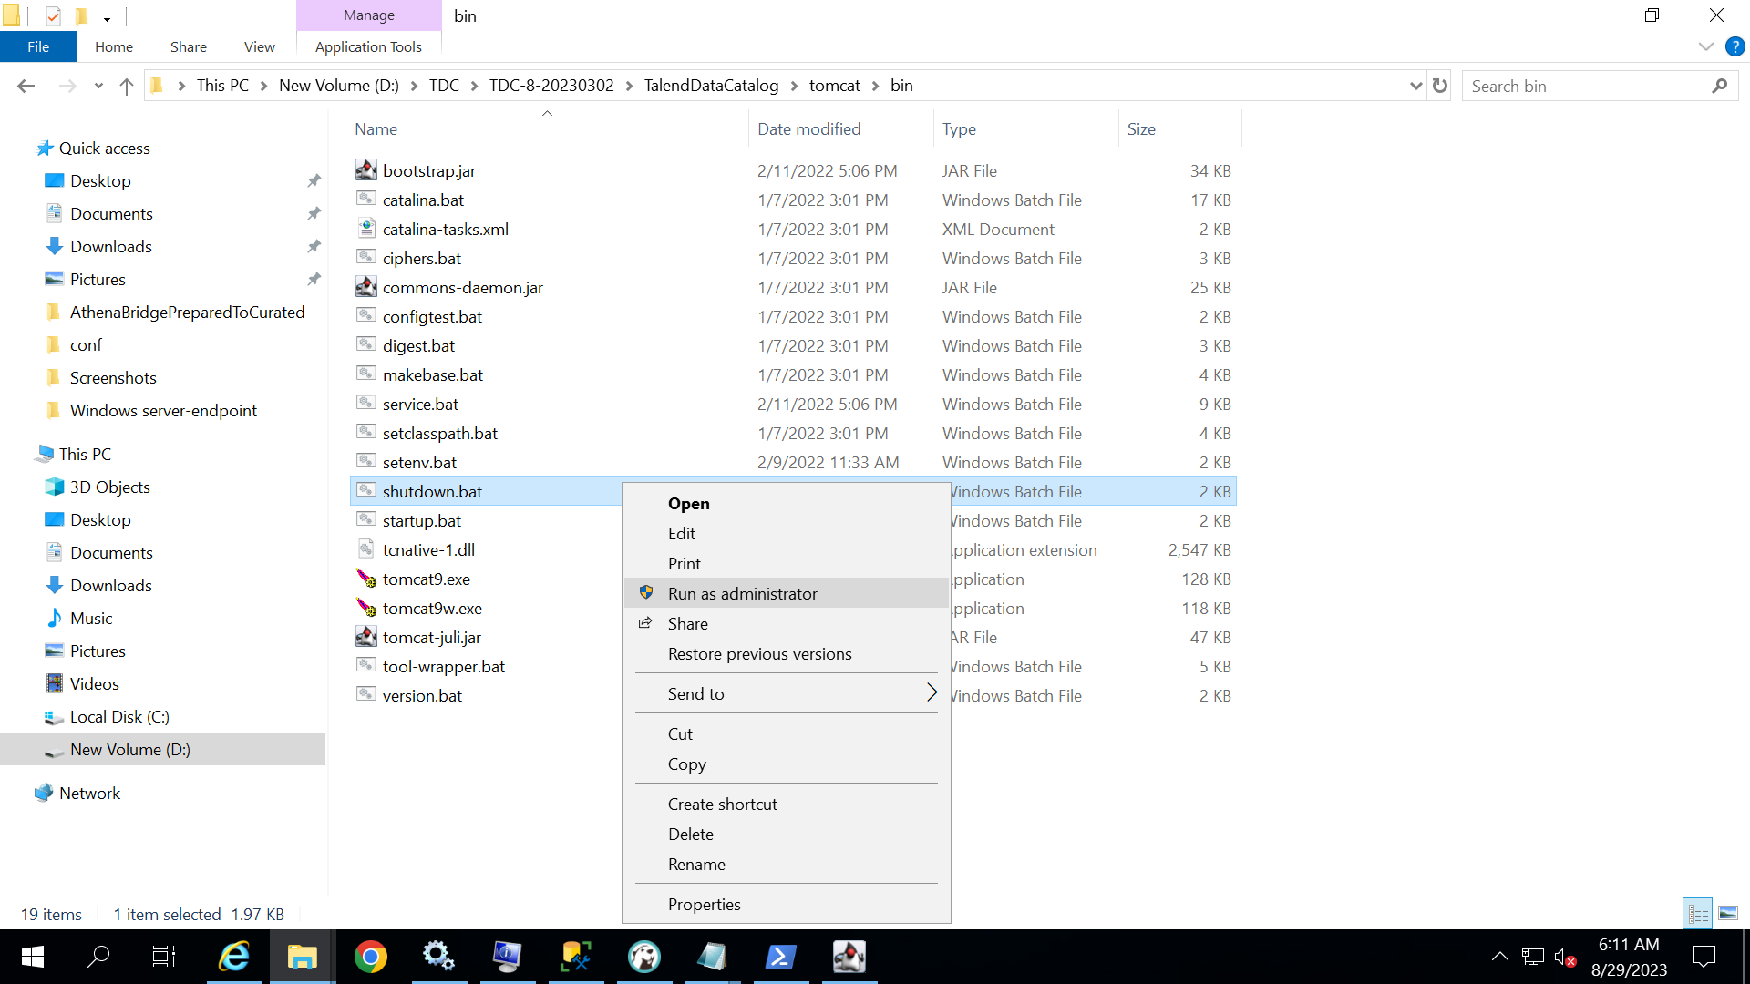

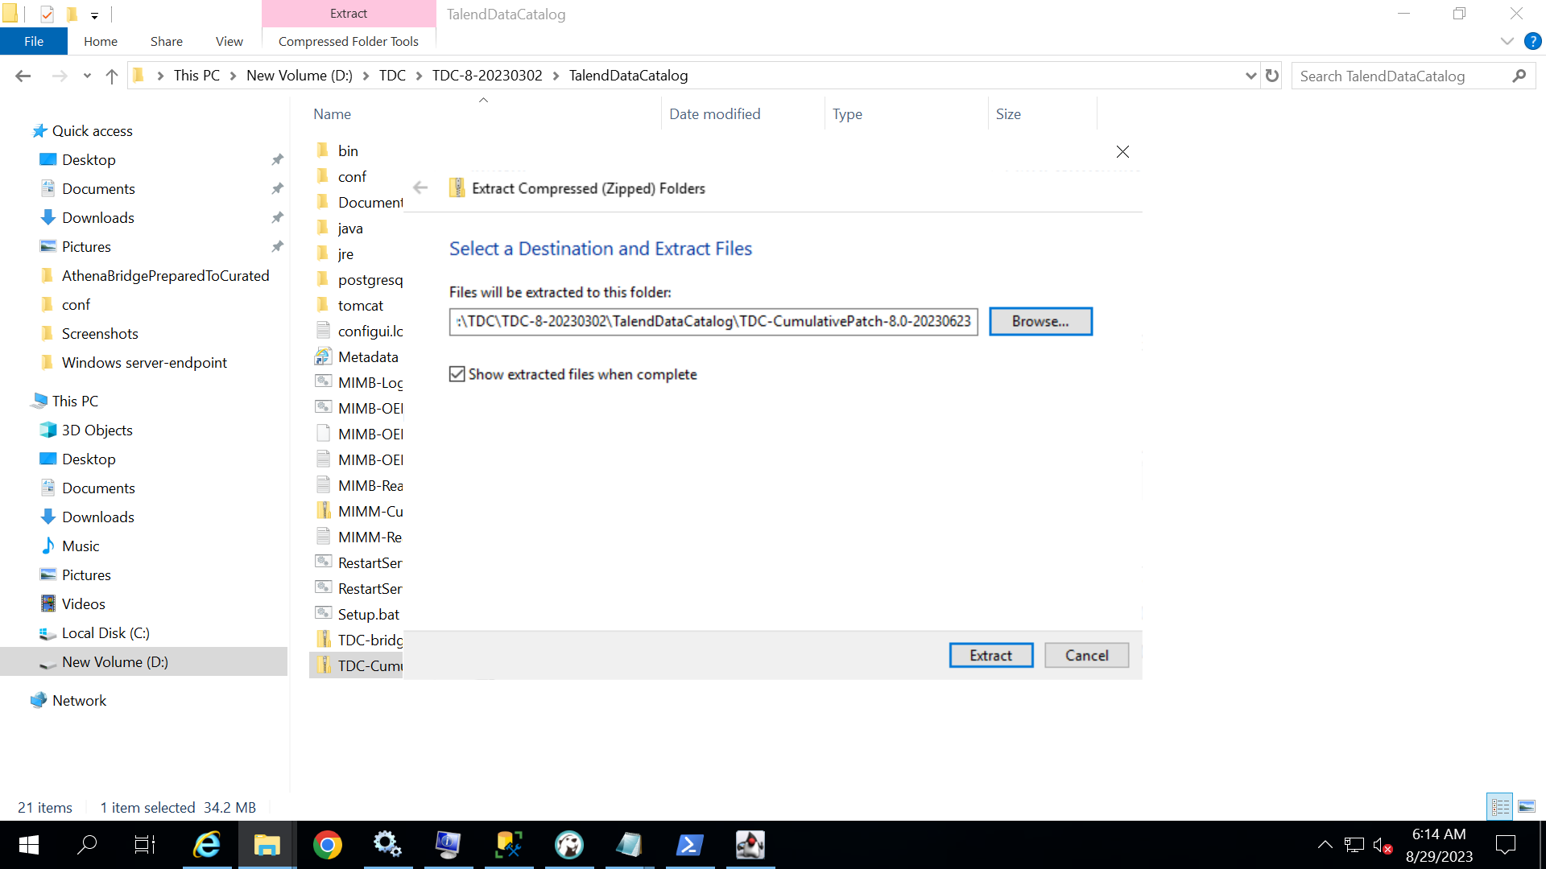Step 4: after stopping the server paste the patch file in the Talend data catalog and right click on the patch and click on extract all.

Step 5: brows the installation directory and extract patch file in the talend data catalog folder and click on extract.

Step 6: go to D:\TDC\TDC-8-20230302\TalendDataCatalog

Step 7: right click on RestartServerApplication.bat and click on run as administrator.

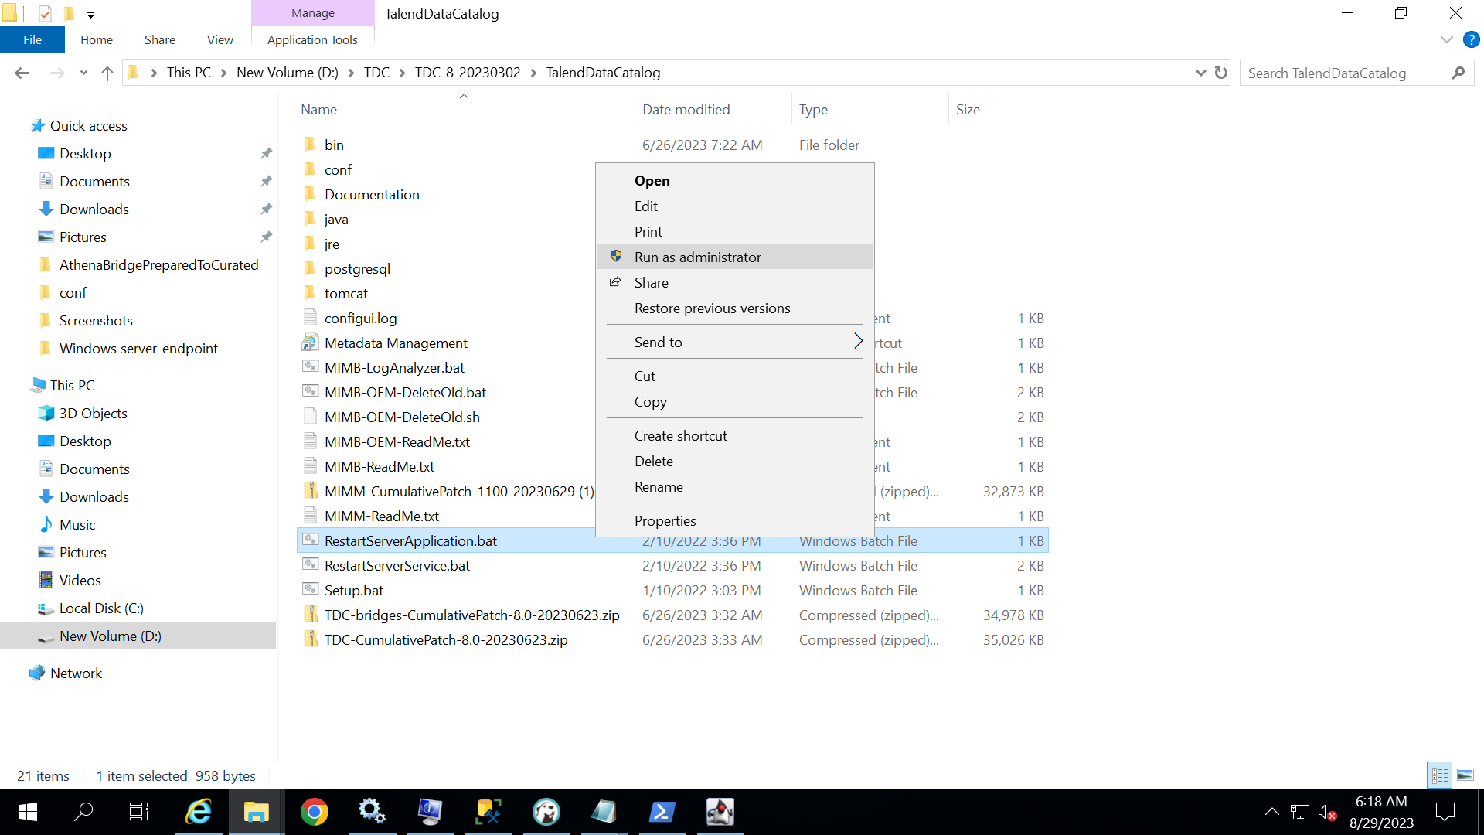

Step 8: after restarting the server application open the application and enter the login credentials and check if patch is successfully applied or not.

Step 9: after entering credentials upgrade database option will come click on that so database will update.

Step 9: for checking patch go to Manage>system

There you can see the latest applied patch.